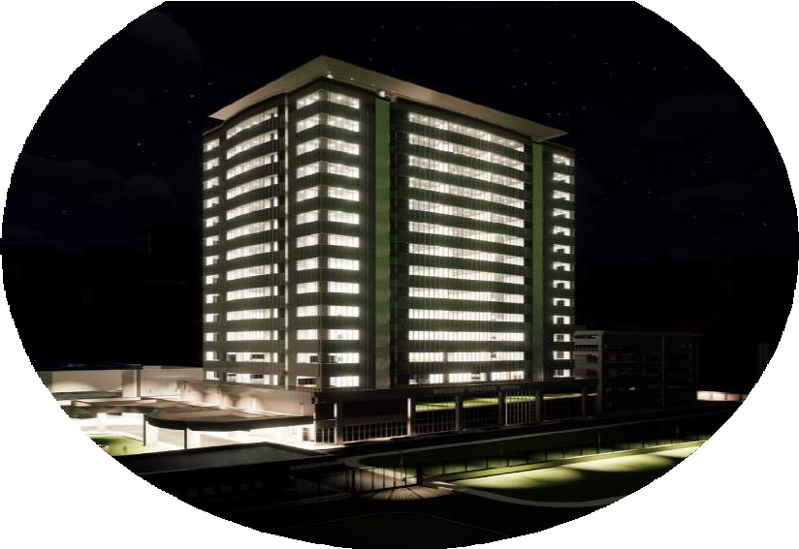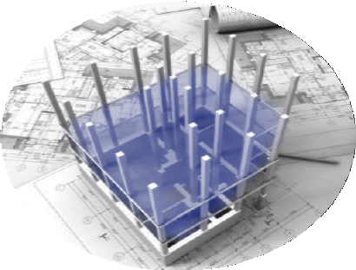

B I M S E R V I C E S

BROCHURE

We digitize and integrate your property development processes of planning, architectural, engineering, construction, operations, and maintenance AECOM processes with data-rich visual models switching

from 2D to 3D, 4D, 5D, and beyond.

 **08022020122**

[**service@maxmigold.com**](mailto:service@maxmigold.com)

**Max-Migold Ltd, HRDC Building, University of Lagos Main Campus, Akoka**

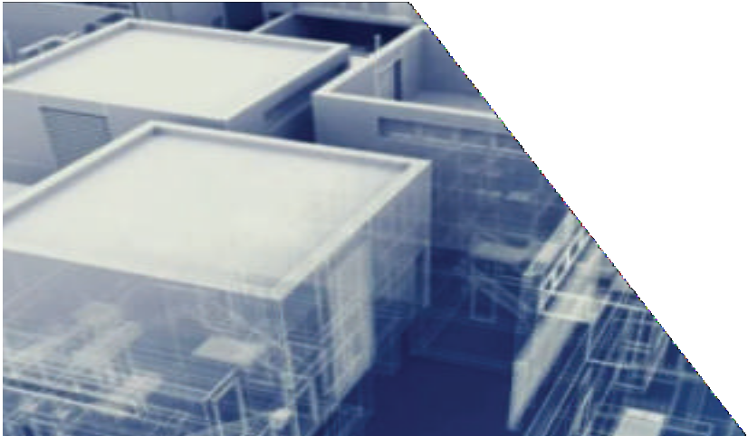

With a long history in facilities management, training, technology, and advisory services, Max-Mi- gold prides itself as a solution provider in the AECOM industry. We are fixing the age-long lack of synergy between design, construction, operations teams, and eventual building users by deploying a Building Information Modelling BIM-based technology solution.

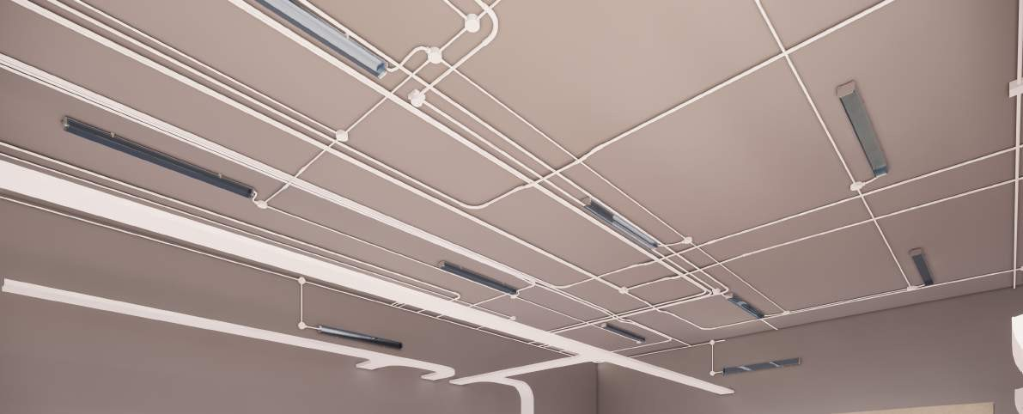

WHY MAX-MIGOLD?

We create a system that aggregates all data for decision-making processes at any given point in a building lifecycle from planning, design, contracting, construction, handover, facility management, renovations, and renewal.

Max-Migold Limited boasts of experts with specialist skills in BIM technologies, multidimensional modeling, engineering, and design who continually improve with up-to-the-minute developments to remain at the forefront of cutting edge technologies in the BIM domain.

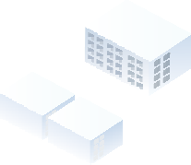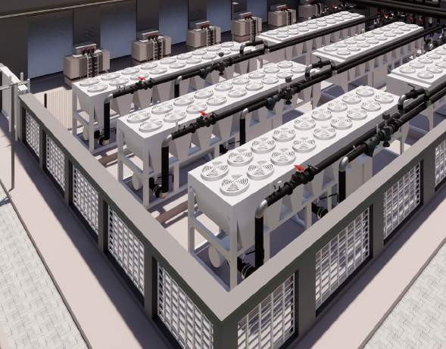

THE BUILDING INFORMATION

MODELLING (BIM) SOLUTION

BIM is the process of combining information and technology to create a digital representa- tion of a project, such as buildings, bridges, roads, process plants, etc. so that multi-disci- plinary professionals and project management stakeholders can collaborate in real time.

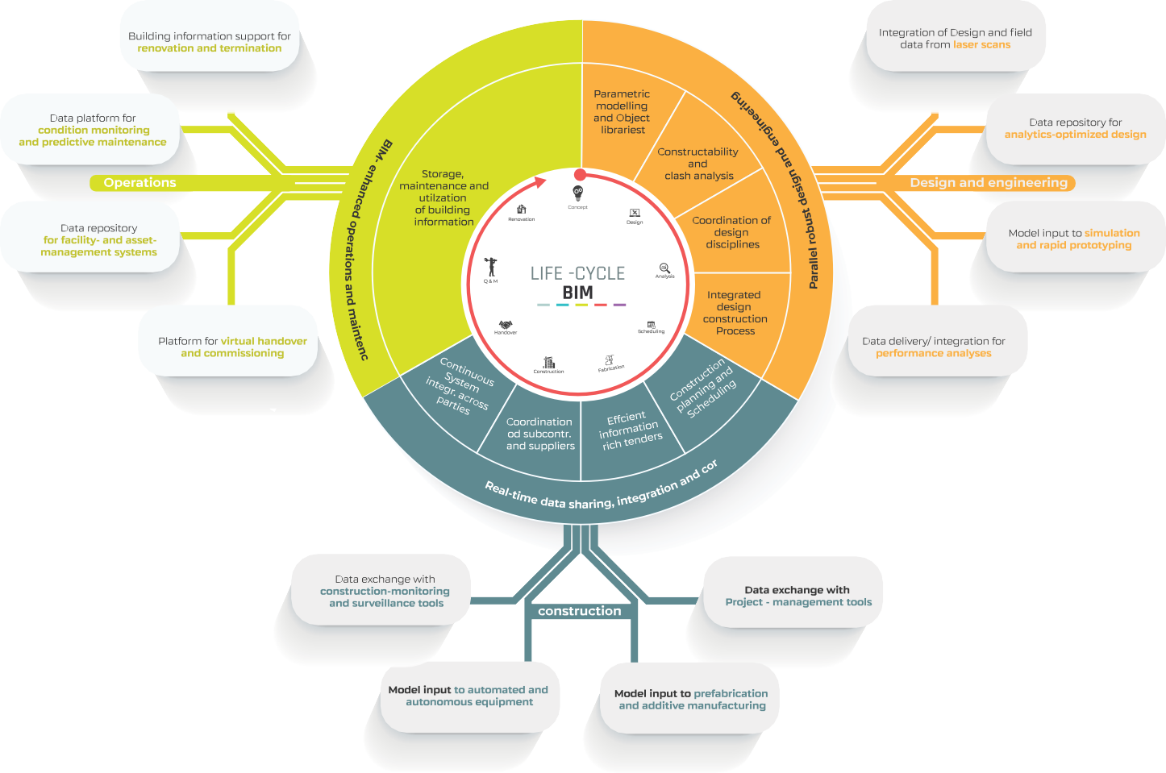

Each discipline or stakeholder can insert, extract, update or modify the data within the modeling process for increased transparency, schedule optimization, clash detection, cost efficiency, resource planning, and overall project effectiveness.

The use of Parametric 3D models to generates facility systems documentation in the BIM process flow enables project changes to be implemented and communicated to all stakeholders, enhancing coordination among various disciplines and saving both time and money while improving project delivery effectiveness.

The end goal of BIM is essentially to provide better information management, empowering asset owners, and managers with a structured set of data for managing a built asset over its useful life.

ARCHITECTURAL MODELLING &

# VISUALISATION

Max-Migold provides detailed visualizations of construction projects with photorealistic multidimensional renderings and virtual walkthroughs from preconstruction to completion.

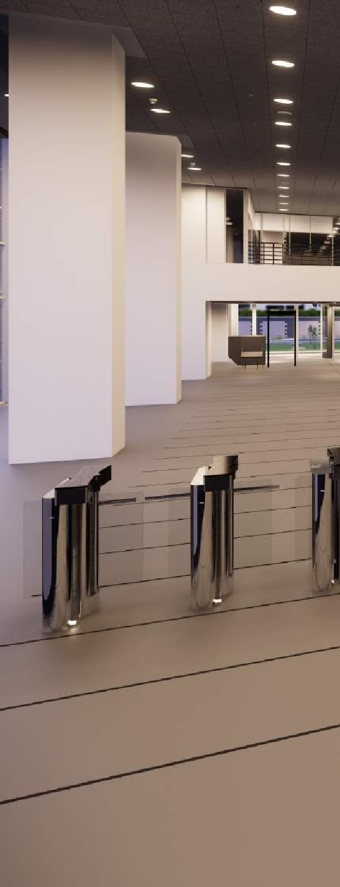

We not only convey aesthetics, but emphasize functionality, ensure

time-effectiveness in design development, closely align designs with clients’ requirements, fast-track project approval, and serve as a proper orientation to

end-users.

Max-Migold uses the BIM technology for visualization in presenting final designs to prospective sales clients, owners, and other stakeholders during project planning and initiation, demonstrating practical construction methods through detailing during construction and building user orientation during handover and occupation.

## **SERVICES:**

We create architectural 3D models with parametric families-based visualization and rendering

Coordination with structural models

We produce construction documentation for permitting, construction, and as-builts use.

Coordination with Mechanical, Electrical, and Plumbing MEP models

Construction work methods detailing and support services

Support the preparation of construction quantities and contract documentation As-built drawings and other as-built docu- mentation

CIVIL/STRUCTURAL

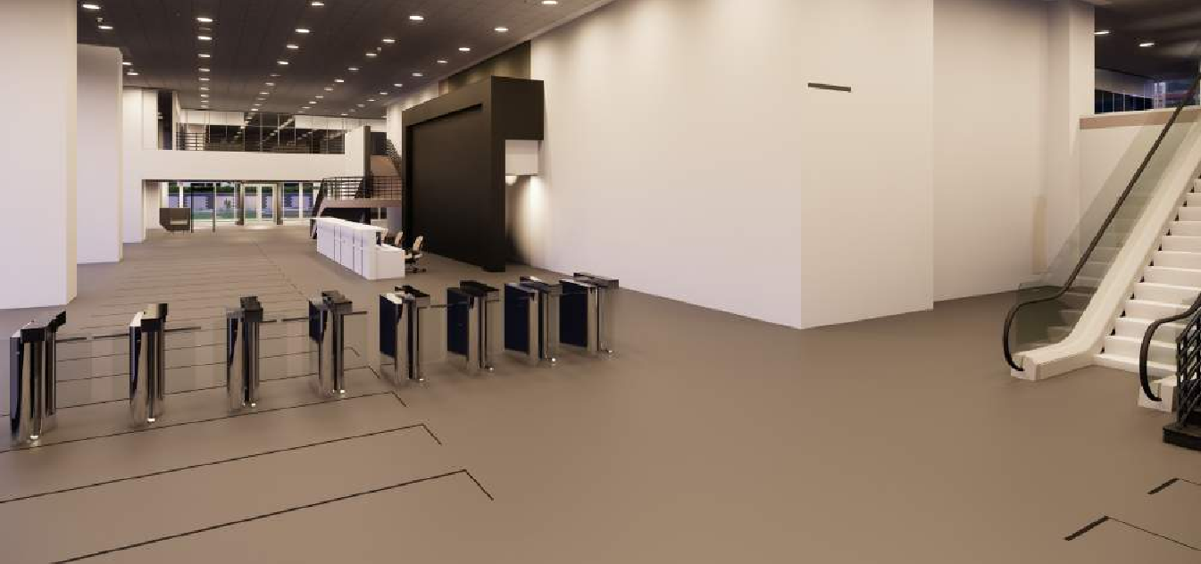

# BIM SERVICES

Max-Migold Limited’s team of experienced Civil/ Structural engineers and BIM specialists work with design teams, engineering teams, steel fabricators, and general contractors, achieving maximum efficiency in construction projects by creating coordinated and accurate structural BIM models.

## **SERVICES:**

We develop multidimensional BIM models with parametric families based on the architec- tural model and structural design

Coordination with architectural BIM models Integrate the structural model with MEP models

Prepare structural documentation for permitting, construction, and as-built documentation.

Concrete, steel, and reinforcement bending detailing for construction

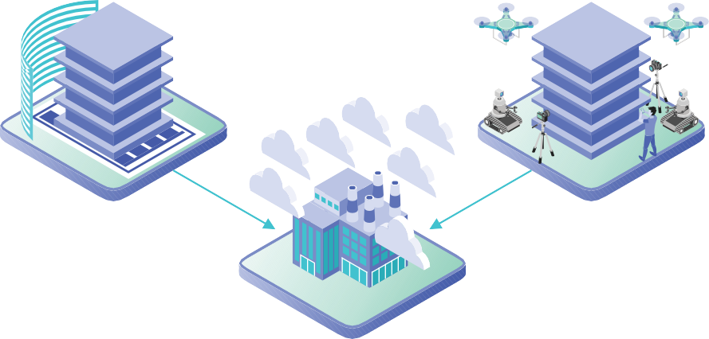

MECHANICAL, ELECTRICAL AND PLUMBING

# MEP BIM SERVICES

Accurate Mechanical, Electrical, and Plumb- ing (MEP) system documentation are crucial to the operation and maintenance of a facility. However, traditional CAD systems do not guarantee the accuracy needed to run a facility effectively. Also, recurrent changes during the construction phase and the preparation of as-built documentation using the traditional CAD system has proven to be problematic.

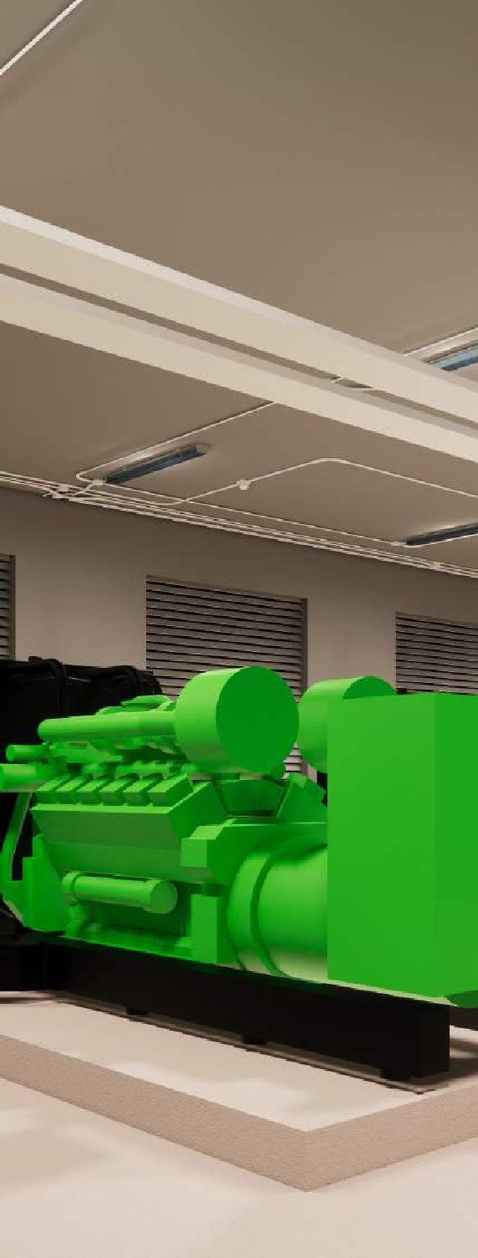

Max-Migold’s BIM specialists collaborate well with Architects, Structural Engineers, Steel Fabricators, and General Contractors to create coordinated and accurate MEP Models. Such models are developed from drawings, IFC files, schematic sketches, submittals, etc.

## **SERVICES:**

Development of detail MEP BIM model for preconstruction (clash detection & coordination)

Development of detail MEP BIM model for post-construction (as-built)

MEP family content creation

MEP documentation for permitting, construction, and as-builts use.

Track and monitor the progress of construction activities.

Detect any technical deficiency and constructability issues.

Cost and time dimensions are captured in the form of 4D or 5D Models

MEP BIM deployment helps the smooth transition from the construction phase to the operations and maintenance with up-to-date information about installed systems.

BIM-BASED CONSTRUCTION

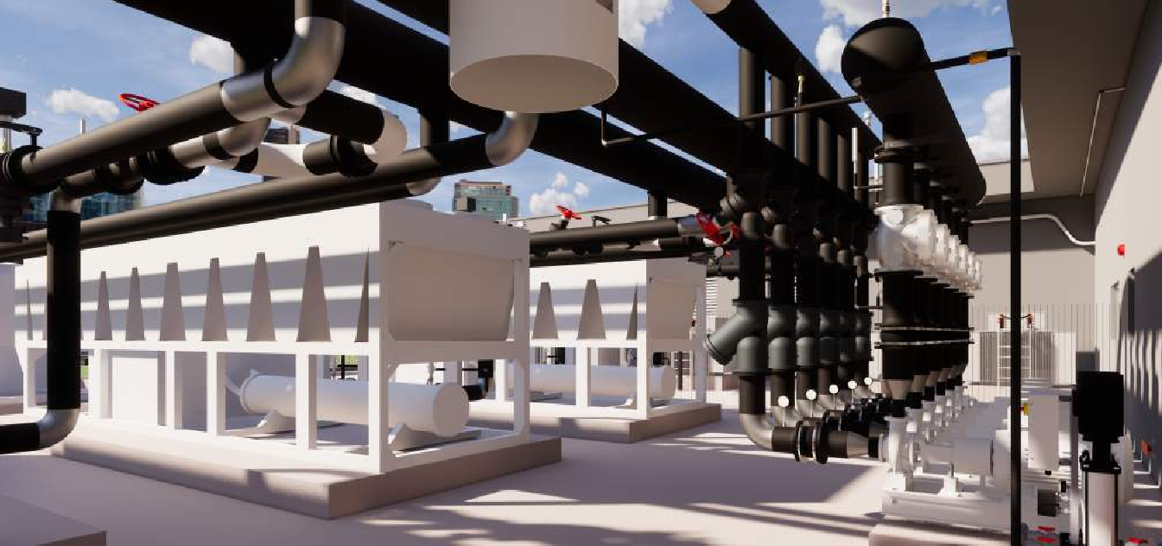

# MANAGEMENT

With the BIM technology, the progress of construction activities is monitored from a reproduced digital version of any point in time. It helps detect any technical deficiency and constructability issues that can serve as impediments to project construction objectives. Also, cost and time dimensions can be captured in 4D or 5D Models to smoothen the construction information flow.

Incorporating BIM into the overall construction management helps the smooth transition from the construction phase to the operations and maintenance of a building lifecycle with up-to-date information about installed systems.

At Max-Migold, given our all-inclusive BIM workflow, we offer a data-driven, transparent construc- tion management workflow with our cloud-based BIM technology.

## **SERVICES:**

Realtime project progress monitoring Proactive issues identification and resolution Data-driven, transparent construction workflow management

Development of 4D and 5D BIM models to add additional insights into the construction data Clash detection and coordination services Development of as-built for operation and maintenance phase

BIM-BASED FACILITIES

# MANAGEMENT

Max-Migold has extensive experience in facilities management consultancy, inspection, and technology advisory, coupled with our experienced engineers and BIM specialists.

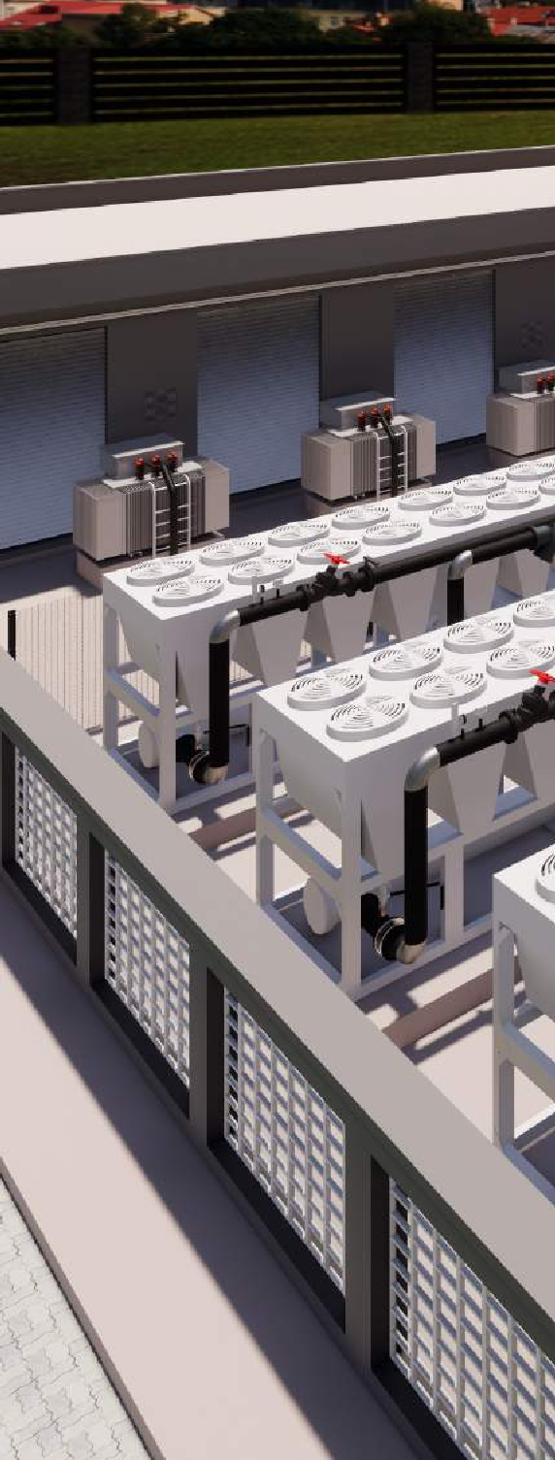

We offer solutions in developing BIM models for asset management that addresses the needs of facilities management professionals to enhance operations and maintenance activities.

Max-Migold collects data and information through a BIM process during the building lifecycle that will reduce the cost and the time required to acquire accurate data for deploying facilities management software.

## **SERVICES:**

Development of an optimized as-built BIM model for facilities management

We configuration a cloud-based document management system from data gleaned during each stage of the property development process

Creation of operations and maintenance manuals database for all project deliverables We develop and digitalize the installed asset register ready for deployment into facilities and enterprise management systems

BIM-based FM System configuration Development of optimized as-built documentation including drawings, component and equipment specifications, materials schedules, warranties, permits, commissioning documentation, bills of quantities, etc.

BIM model for facilities management operations, maintenance, renovations, and remodeling projects

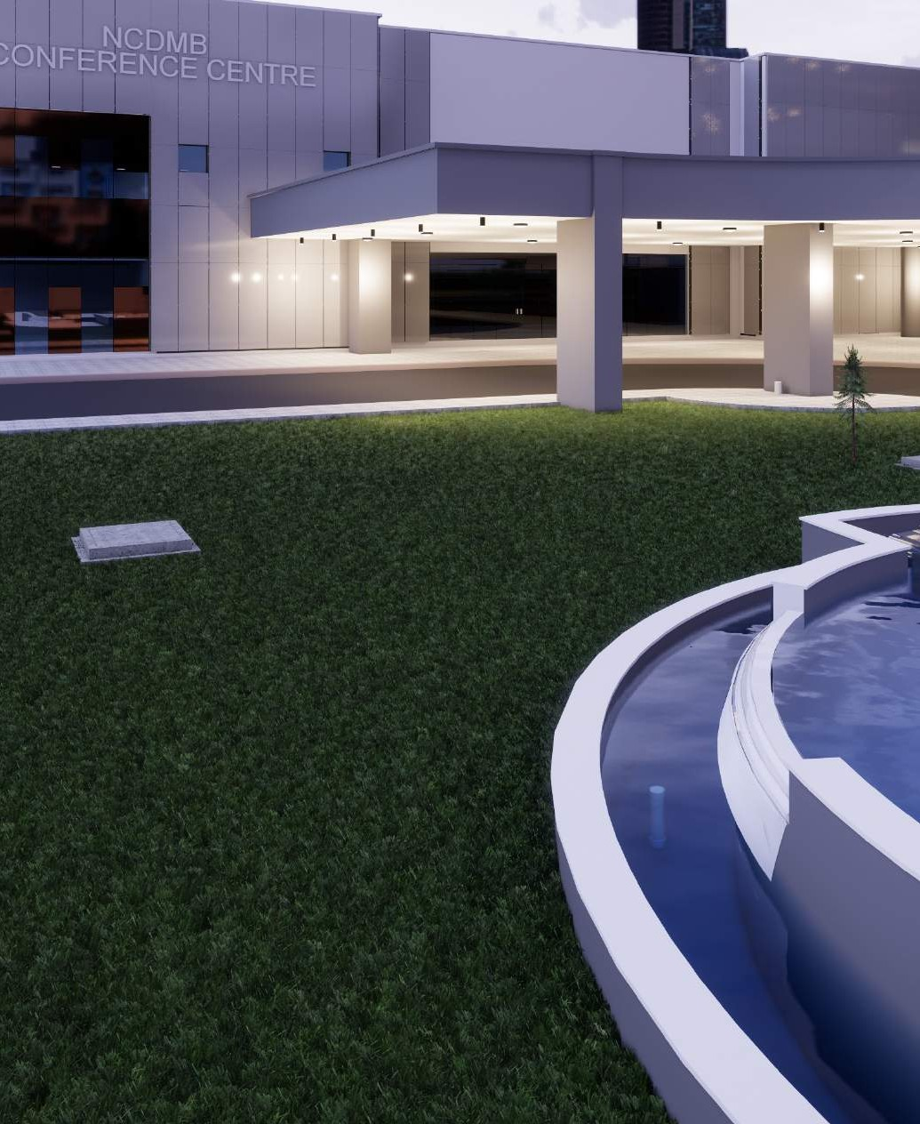



**Max-Migold Ltd, HRDC Building,**

**University of Lagos Main Campus, Akoka**

**08022020122**

[**service@maxmigold.com**](mailto:service@maxmigold.com)